Women's Bible Study
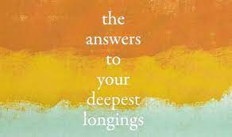
Every other Tuesday night @ 7pm
In the Community Room

Mark these dates on your calendar:

May 4: Longing for Purpose
May 18: Longing for Freedom
June 8: Longing for Security
June 15: Longing for Rescue
June 29: Longing for Redemption
July 13: Longing for Fulfillment
July 27: Longing for Identity
Aug. 10: Longing for Christ's Return
Aug. 24: Wrap-Up Celebration

*Free Bible Study books will be provided*
Led by Gina Hughes & Debby Mircheff

To register text Martha Sanchez @ (562)267-7971

